Test Case: tc002_SPX_Dev5_Crear_Requisicion_Spot_Tipo_Cobro_Project
Step 1 - Enter username and password and click to button Enter: Credentials Entered
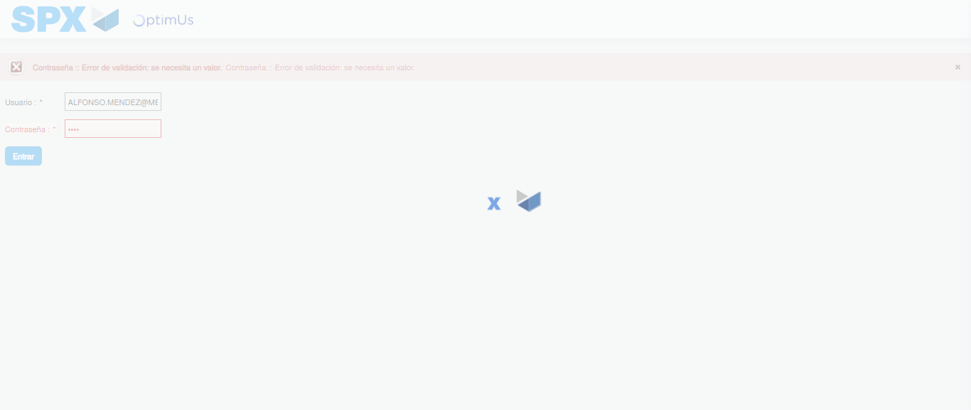Image file-name: QC_Testing-tc002_SPX_Dev5_Crear_Requisicion_Spot_Tipo_Cobro_Project-1783382286677

Step 2 - Select to UEN and Access to Spot Buy Requisitions : UEN Correctly selected and Correct access
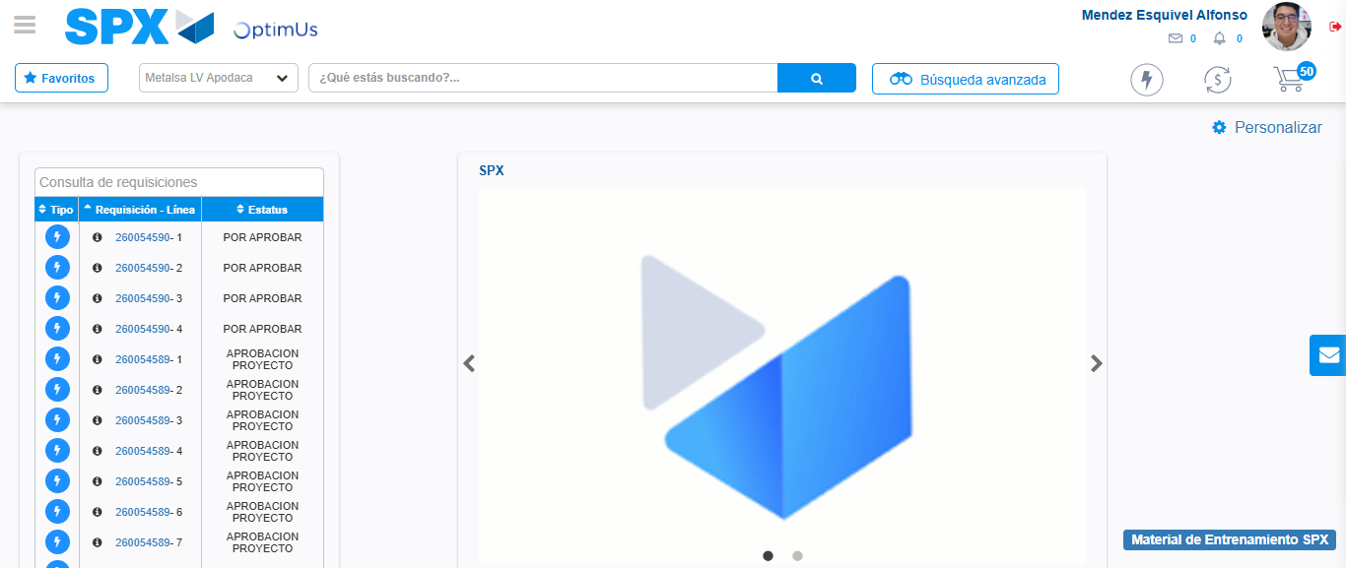Image file-name: QC_Testing-tc002_SPX_Dev5_Crear_Requisicion_Spot_Tipo_Cobro_Project-1783382312464

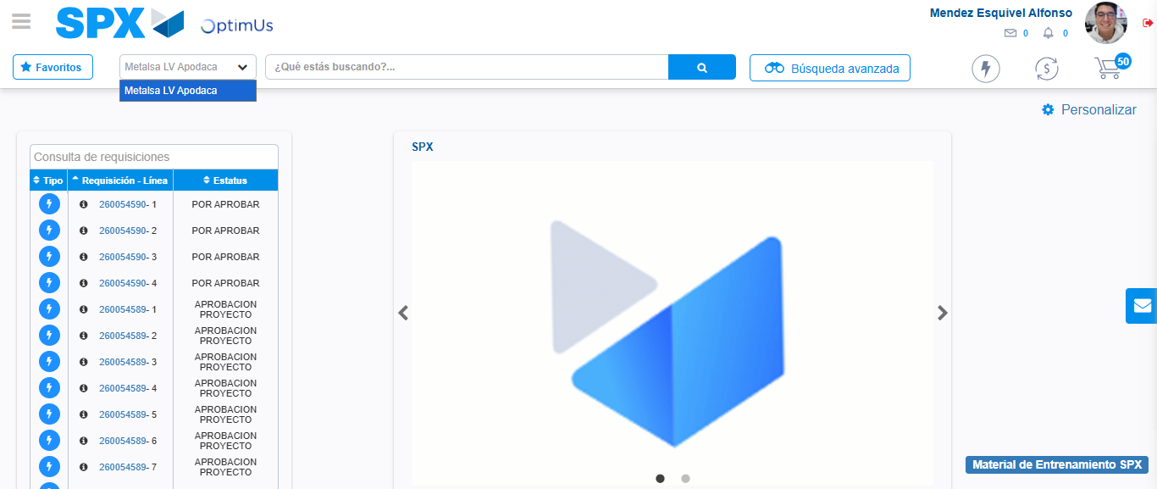Image file-name: QC_Testing-tc002_SPX_Dev5_Crear_Requisicion_Spot_Tipo_Cobro_Project-1783382314935

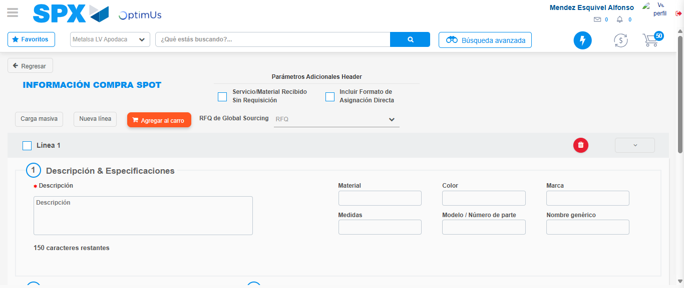Image file-name: QC_Testing-tc002_SPX_Dev5_Crear_Requisicion_Spot_Tipo_Cobro_Project-1783382353783

Step 3 - Data Capture Spot Buy Requisition: Data captured correctly
Image file-name: QC_Testing-tc002_SPX_Dev5_Crear_Requisicion_Spot_Tipo_Cobro_Project-1783382354054

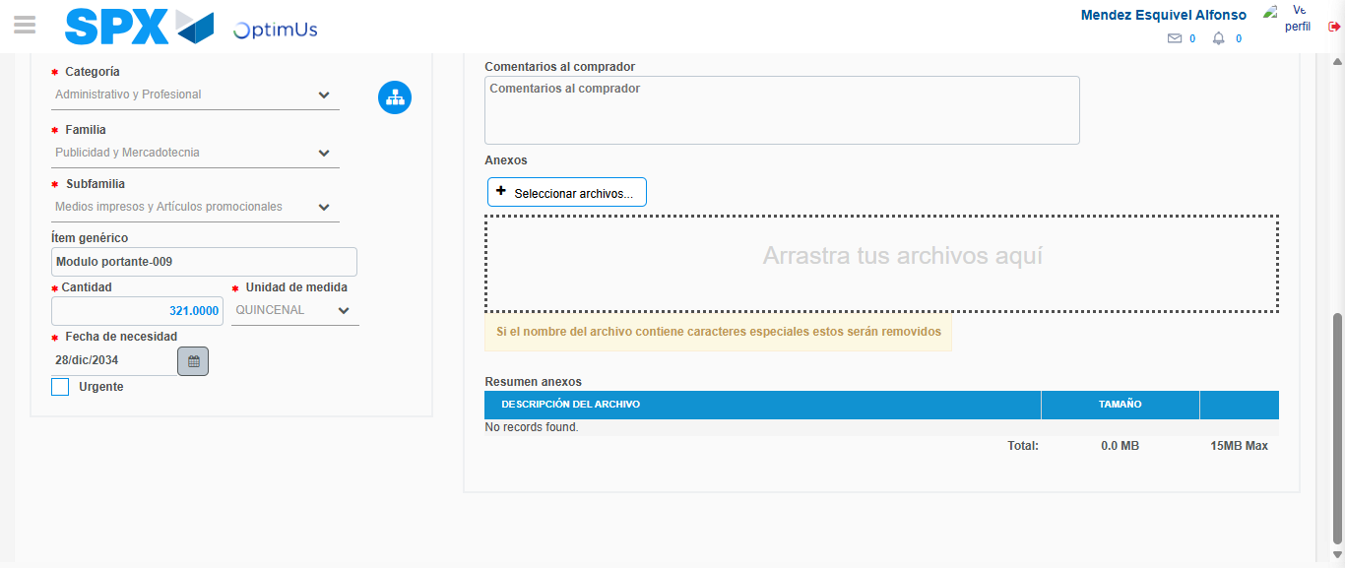Image file-name: QC_Testing-tc002_SPX_Dev5_Crear_Requisicion_Spot_Tipo_Cobro_Project-1783382364309

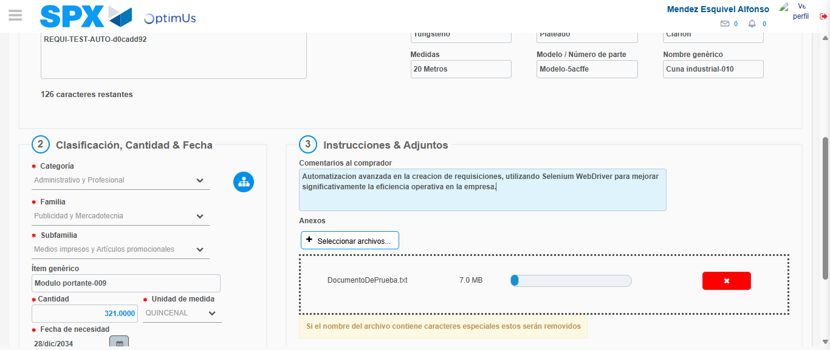Image file-name: QC_Testing-tc002_SPX_Dev5_Crear_Requisicion_Spot_Tipo_Cobro_Project-1783382365065

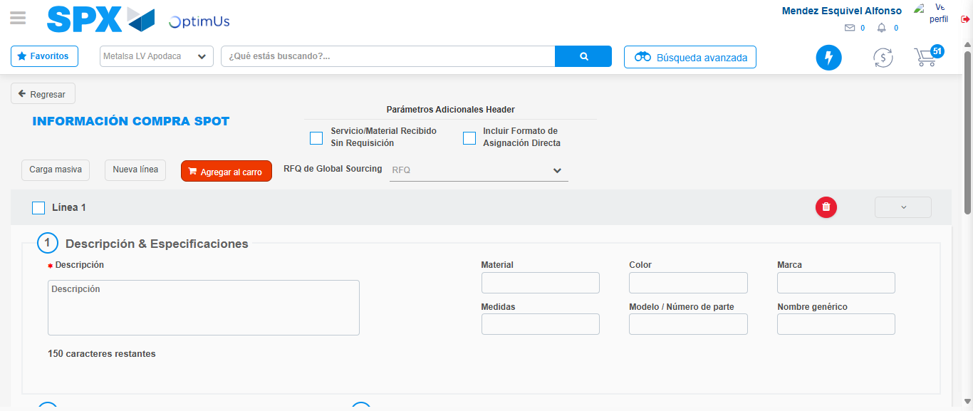Image file-name: QC_Testing-tc002_SPX_Dev5_Crear_Requisicion_Spot_Tipo_Cobro_Project-1783382371919

Step 7 - Return to Main Page SPX : Return to Main Page SPX
Image file-name: QC_Testing-tc002_SPX_Dev5_Crear_Requisicion_Spot_Tipo_Cobro_Project-1783382312464

Image file-name: QC_Testing-tc002_SPX_Dev5_Crear_Requisicion_Spot_Tipo_Cobro_Project-1783382314935

Image file-name: QC_Testing-tc002_SPX_Dev5_Crear_Requisicion_Spot_Tipo_Cobro_Project-1783382353783

Image file-name: QC_Testing-tc002_SPX_Dev5_Crear_Requisicion_Spot_Tipo_Cobro_Project-1783382374160

Image file-name: QC_Testing-tc002_SPX_Dev5_Crear_Requisicion_Spot_Tipo_Cobro_Project-1783382374323

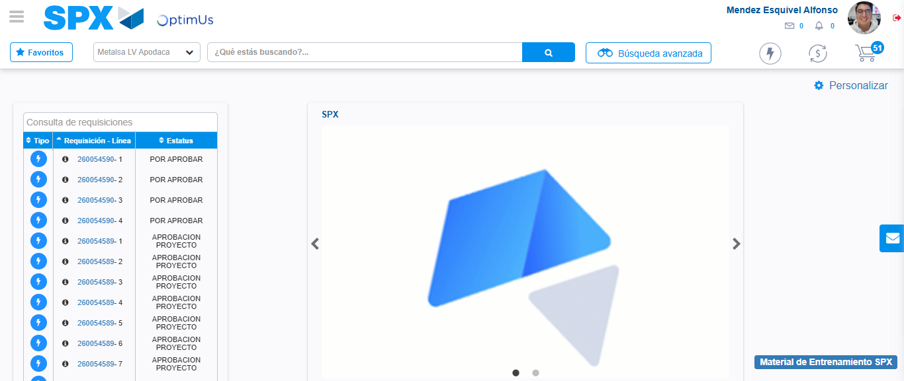Image file-name: QC_Testing-tc002_SPX_Dev5_Crear_Requisicion_Spot_Tipo_Cobro_Project-1783382395391

Step 8 - Log Out : Log Out SPX
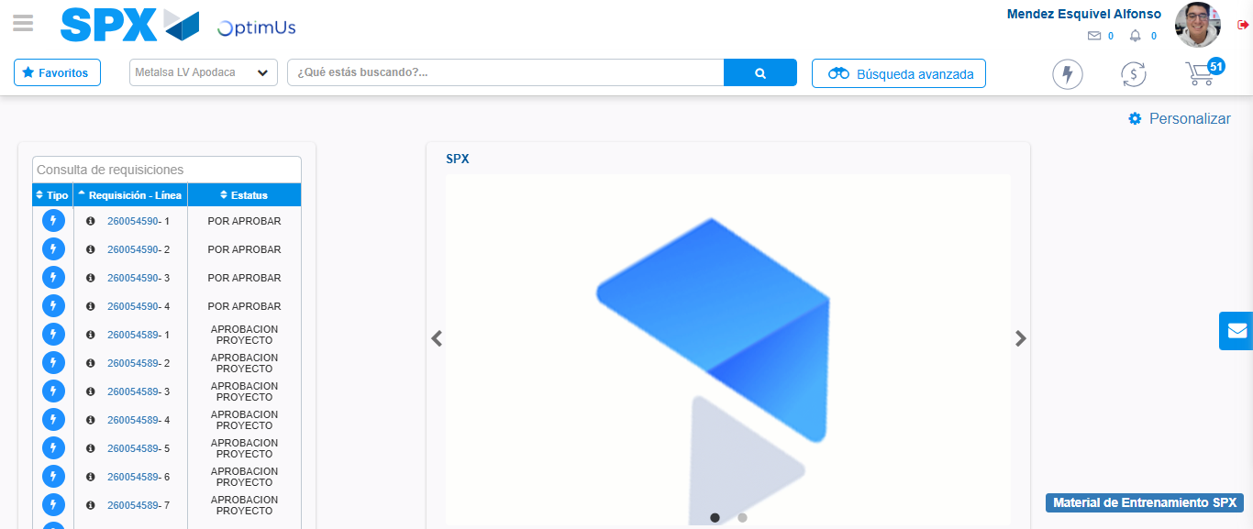Image file-name: QC_Testing-tc002_SPX_Dev5_Crear_Requisicion_Spot_Tipo_Cobro_Project-1783382395648

